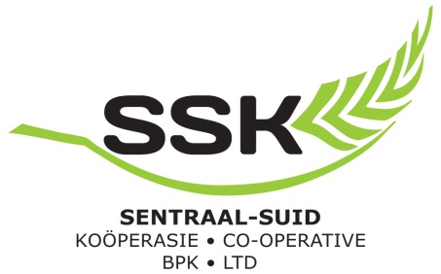
AANSOEKVORM OM DONASIE OF BORGSKAP
APPLICATION FOR A DONATION OR SPONSORSHIP
Voltooide aansoekvorms kan ingehandig word by die SSK administrasie takke in Swellendam, Heidelberg en Mosselbaai of ge-epos word aan die kontak persone gemeld hieronder:
Completed application forms can be handed in at the SSK administrative branches in Swellendam, Heidelberg and Mossel Bay or e-mailed to the contact persons noted below:
Swellendam: Wilna van der Merwe Tel: (028) 514 8611
E pos: wilna.vandermerwe@ssk.co.za
Heidelberg: Simonique Uys Tel: (028) 514 8707
E pos: simonique.uys @ssk.co.za
Mosselbaai: Annelie van Wyk Tel: (044) 601 1270
E pos: annelie.vanwyk@ssk.co.za
 | Naam van Organisasie / Name of Organisation:
 | Kontakpersoon / Contact Person:
 | Ampsposisie / Designation:
 | Fisiese Adres / Physical Address:
 | Posadres / Postal Address:
 | Telefoonnommer / Telephone number:
 | E-pos adres / E-mail Address:
 | Webadres / Web Address:
 | Kan u organisasie ‘n SARS 18A sertifikaat uitreik vir die donasies? /  Can your organisation issue an SARS 18A certificate for the donations? |  | YES / NO

5. Gee ‘n kort beskrywing van die aard van u besigheid of organisasie / Give a brief description of the nature of your business or organisation:
…………………………………………………………………….……………………………………………………………………………………
………………………………………………………………….…….…..……………………………………………………………………………
…………………………………………………………………….….…..……………………………………………………………………………
6. Bedrag/dienste/produkte voor aansoek gedoen / Amount/services/products applied for:
………………………………………………………..……………………………………………………………………………………………….
………………………………………………………..……………………………………………………………………………………………….
7. Teen watter datum word die donasie verlang?/ At what date is the donation required?
………………………………………………………….……………………………………………………………………………………………..
8. Gee ‘n kort beskrywing van die doel en projekte waarvoor die bedrag/e aangewend sal word en wie die begunstigdes sal wees / Give a brief description of the purposes and projects for which the amounts will be used for and whom the beneficiaries will be:
……………………………………………………………………….……………………………….………………………………………………..
……………………………………………………………………….……………………………….………………………………………………..
………………………………………………………………………..…..……………………………………………………………………………
………………………………………………………………………….……………….………………………………………………………………
9. Watter persentasie van hierdie begunstigde is swart in terme van die heersende SEB Wetgewing? What percentage of the said beneficiaries can be classified as black in terms of the BBBEE legislation?
……………………………………………………………………………………………………………………………………………………...
10. Was daar al ‘n soortgelyke projek in die verlede geloods? Gee asb. besonderhede indien wel / Has a similar project been launched in the past? If so please provide details :
………………………………………………….……………………………………………………………………………………………………..
……………………………………………………………….………………………………………………………………………………………..
…………………………………………………………………………….…………………………………………………………………………..
……………………………………………………………………….……………………………….………………………………………………..

11. Is die projek afhanklik van donasies van ander organisasies? Indien ja, gee besonderhede van pogings aangewend om sulke donasies te bekom by die datum van hierdie aansoek / Is the project dependent on donations from other organisations? If yes, give details of attempts made to secure such donations and the success thereof at the time of this application:
……………………………..…………………………………………………………………………………………………………………………
……………………………………….…………….…………………………………………………………………………………………………
………………………………………………….….…………………………………………………………………………………………………
12. Enige ander besonderhede of motivering wat as relevant en belangrik geag word / Any additional details or motivation deemed as relevant and important:
…………………………………………………………………………………………………………………………………………………………
………………………………………………………………………………..………….……………………………………………………………
…………………………………………………………………………………………………………………………………………………………
13. Heg asseblief ‘n amptelike briefhoof van u organisasie aan, asook ‘n bankgewaarborgde tjek of brief met bankstempel / Please attach a copy of an official letterhead of your organisation as well as a bank guaranteed cheque or letter confirming your banking detail with an official bank stamp.
Naam/Name:
Handtekening/Signature:
Plek/Location:
Datum/Date:

